Why Data Visualization?

When working on any data science project, one of the essential steps to explore and interpret your results is to visualize your data. At the beginning of the project, visualizing your data helps you understand it better, find patterns and trends.

At the end of the project, after you’ve done your analysis and applied different machine learning models, data visualization will help you communicate your results more efficiently.

Humans are visual creatures by nature; things make sense to us when it’s represented in an easy to understand visualization. It’s way easier to interpret a bar chart than it is to look at massive amounts of numbers in a spreadsheet.

Efficient data visualization can make or break your project. If you put tons of effort into analyzing and modeling your data, but you ended up using the wrong chart type to present your results, your audience will not grasp the effort you put in or how to use these results.

How to choose the right chart???

Ask yourself a few very critical questions about your data.

#1. What’s the story your data is trying to deliver?

i. Do you want to compare values?
E.g. Column, Bar, Pie, Line, Scatter Plot, Bullet

ii. Do you want to show the composition of something?
E.g. Pie, Stacked Bar, Stacked Column, Area, Waterfall

iii. Do you want to understand the distribution of your data?
E.g. Scatter Plot, Line, Column, Bar

iv. Are you interested in analyzing trends in your data set?
E.g. Line, Dual-Axis Line, Column

v. 5. Do you want to better understand the relationship between value sets?
E.g. Scatter Plot, Bubble, Line

#2. How big is your data?

The size of your data will significantly affect the type of chart you will use. Some types of charts are not meant to be used with massive datasets, while others are perfect for big data.

For example, pie charts work best with a small number of datasets; however, if you’re using a significant amount of datasets, using a scatter plot will make more sense.

You need to select a chart type that fits the size of your data best and represents it clearly without cluttering.

#3. What is your data type?

There are several types of data, describe, continuous, qualitative, or categorical. You can use the kind of data to eliminate some chart types.

For example, if you have continuous data, a bar chart may not be the best choice; you may need to go with a line chart instead.

Similarly, if you have categorical data, then using a bar chart or a pie chart may be a good idea. You probably will not want to use a line chart with categorical data, because by definition, you can’t have continuous categories. The has to be a discrete finite amount of categories.

Bar charts are good for comparisons, while line charts work better for trends. Scatter plot charts are good for relationships and distributions, but pie charts should be used only for simple compositions — never for comparisons or distributions.

Bar Chart

When to use:
- Comparing parts of a bigger set of data, highlighting different categories, or showing change over time.
- Have long categories label — it offers more space.
- If you want to illustrate both positive and negative values in the dataset.
When to avoid:
- If you’re using multiple data points.
- If you have many categories, avoid overloading your graph. Your graph shouldn’t have more than 10 bars.

Pie Chart

When to use:
- When you show relative proportions and percentages of a whole dataset.
- Best used with small datasets — also applies to donut charts.
- When comparing the effect of ONE factor on different categories.
- If you have up to 6 categories.
- When your data is nominal and not ordinal.
When to avoid:
- If you have a big dataset.
- If you want to make a precise or absolute comparison between values.

Line Chart
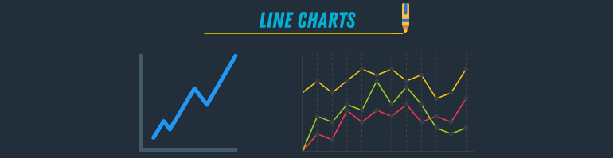

When to use:
- If you have a continuous dataset that changes over time.
- If your dataset is too big for a bar chart.
- If you want to display multiple series for the same timeline.
- If you want to visualize trends instead of exact values.
When to avoid:
- Line charts work better with bigger datasets, so, if you have a small one, use a bar chart instead.

Scatter Plot

When to use:
- To show correlation and clustering in big datasets.
- If your dataset contains points that have a pair of values.
- If the order of points in the dataset is not essential.
When to avoid:
- If you have a small dataset.
- If the values in your dataset are not correlated.

Area Chart

When to use:
- If you want to show part-to-whole relations.
- If you want to portray the volume of your data and not just the relation to time.
When to avoid:
- It can’t be used with discrete data.

Bubble Chart

When to use:
- If you want to compare independent values.
- If you want to show distribution or relation.
When to avoid:
- If you have a small dataset.

Chart Selection Tips
Whenever you decide to create some data visualization, use these best practices to make it more straightforward and effective.
- If you have categorical data, use a bar chart if you have more than 5 categories or a pie chart otherwise.
- If you have nominal data, use bar charts or histograms if your data is discrete, or line/ area charts if it is continuous.
- If you want to show the relationship between values in your dataset, use a scatter plot, bubble chart, or line charts.
- If you want to compare values, use a pie chart — for relative comparison — or bar charts — for precise comparison.
- If you want to compare volumes, use an area chart or a bubble chart.
- If you want to show trends and patterns in your data, use a line chart, bar chart, or scatter plot.

